Cyber Security Controls in Nuclear Power Plant by Technical Assessment Methodology

INDEX
- INTRODUCTION
  - Purpose
  - Scope
  - Model Diagrams
  - Overview
- Literature survey
- System Analysis
  - Existing System & Disadvantages
  - Problem Statement
  - Proposed System & Advantages
- System Requirements Specification
  - Functional Requirements
  - Non-Functional Requirements.
  - Hardware Requirements
  - Software Requirements
- System design
  - System Specifications
  - System Components (Modules)
  - UML/DFD’s
- Implementation
  - Sample Code
- System Testing
  - Types of Testing
  - Test Cases
  - Discussion of Results (Screen Shots)
- Conclusion and Future Enhancements
  - Conclusion
  - Future Enhancements
- References

Cyber Security Controls in Nuclear Power Plant by Technical Assessment Methodology

ABSTRACT :-

With the rapid increase in cyber attacks on industrial control systems, the significance of the application of cyber security controls and the evaluation of security against such attacks has also increased. Among them, cyber attacks on nuclear power plants (NPPs) can cause not only economic loss, but also human casualties. Thus, the application of cyber security controls is necessary for mitigating security threats, especially to NPPs. However, currently, there are limited resources pertaining to information protection, which is essential to uniformly deploy all the controls required to meet cyber security regulations. To overcome this challenge, effective cyber security controls need to be identified and adequate information protection resources must be allocated to each NPP. Although NPPs apply a differential security control according to its characteristics based on NEI 13-10 (Cyber Security Control Assessments), this alone is not only insufficient in reflecting the latest security threats, but also fails to confirm whether the security controls have actually mitigated such threats. To address this challenge, the Electric Power Research Institute (ETRI) developed the technical assessment methodology (TAM), which can be used to generate a quantitative score by assessing the effects of potential cyber attacks on an asset and the relevant security controls. This methodology allows for the application of differential security control based on the score to identify whether the security controls have actually mitigated the risks. Considering this context, the purpose of this paper is to conduct a comparative analysis of the results derived from applying security controls and assessing risks using only NEI 13-10 as well as both NEI 13-10 and TAM on the plant protection system of the nuclear power reactor APR1400. Furthermore, this paper discusses the scopes for subsequent research by addressing the limitations of the TAM and considerations for its use.

1. INTRODUCTION
The digital transformation of industrial control systems (ICS), while bringing significant improvements in efficiency and functionality, has concurrently expanded the attack surface for malicious cyber activities. This trend is particularly pronounced in critical national infrastructure, where the convergence of information technology (IT) and operational technology (OT) has introduced new vulnerabilities . Recent reports indicate a dramatic increase in attacks on operational technology, highlighting that critical infrastructures have become primary targets for adversaries . Within this landscape, nuclear power plants (NPPs) represent one of the most sensitive and high-consequence targets. A successful cyber attack on an NPP could lead not only to significant economic losses but also to catastrophic human casualties and widespread environmental damage, making robust cybersecurity not merely an operational requirement but a fundamental societal necessity .
The application of systematic cybersecurity controls is therefore paramount for mitigating these evolving threats. Regulatory bodies and industry bodies have established frameworks and standards to guide NPP operators in this endeavor . However, a universal and uniform deployment of all prescribed controls is often impractical due to finite resources—including budget, personnel, and time—dedicated to information protection. This resource constraint necessitates a strategic approach to identify the most effective controls and allocate resources efficiently where they are most needed . Currently, frameworks like NEI 13-10 (Cyber Security Control Assessments) provide a foundational approach for applying differential security controls based on asset characteristics. While valuable, this static, compliance-oriented method alone is insufficient for two primary reasons: it struggles to adapt to the rapidly evolving threat landscape, and more importantly, it does not empirically confirm whether the implemented controls have actually mitigated the identified risks .
To address this critical gap, the Electric Power Research Institute (EPRI) developed the Technical Assessment Methodology (TAM). TAM is a performance-based approach designed to evaluate the effectiveness of cybersecurity controls on a specific asset . It functions by assessing potential cyber attack vectors against an asset and the corresponding security controls in place, generating a quantitative score. This score enables a risk-informed application of differential security controls and, crucially, provides a mechanism to verify if those controls are sufficient to mitigate the risk to an acceptable level . TAM has been recognized and utilized in international contexts, such as for cybersecurity assessments at the Barakah Nuclear Power Plant in the United Arab Emirates, underscoring its practical relevance . Given this context, this paper seeks to explore the tangible benefits of integrating a performance-based methodology with a traditional compliance framework. It will conduct a comparative analysis of risk assessment outcomes on a critical NPP system using NEI 13-10 in isolation, and then in conjunction with EPRI's TAM.

1.1. Purpose
The primary purpose of this paper is to perform a detailed comparative analysis of cybersecurity risk assessment results derived from two different approaches applied to the plant protection system of the APR1400 nuclear power reactor. The first approach relies solely on the NEI 13-10 framework for applying security controls and assessing risks. The second approach integrates the results of NEI 13-10 with the quantitative, performance-based Technical Assessment Methodology (TAM) developed by EPRI . The core objective is to determine how the inclusion of TAM alters the risk perspective, control prioritization, and resource allocation decisions compared to using NEI 13-10 alone. Furthermore, this paper aims to identify whether the combined methodology provides a more robust confirmation that security controls are effectively mitigating risks. Finally, this study will critically discuss the limitations inherent in the TAM methodology and outline important considerations for its practical application in the field, thereby charting directions for subsequent research .

1.2. Scope
The scope of this research is specifically confined to the plant protection system of the APR1400 (Advanced Power Reactor 1400), a prominent Korean-designed nuclear reactor . The plant protection system, which includes the Reactor Protection System (RPS), is a safety-critical system responsible for initiating an automatic reactor trip when parameters exceed predefined limits, making its security of paramount importance . The analysis will focus on the cybersecurity controls applicable to this digital safety system.
The research will involve:
- A review of the security controls required and recommended for the APR1400's plant protection system based on the NEI 13-10 framework.
- A separate application of the EPRI TAM to the same system, following its structured process of asset analysis, exploit sequence identification, and control scoring .
- A comparative analysis of the findings from both methods, focusing on identified risks, the perceived effectiveness of controls, and residual risk.
The scope explicitly excludes a full-scale, live penetration test of an operational plant protection system. The analysis will be based on system design documentation, architectural diagrams, and established vulnerability information, consistent with a conceptual or design-stage assessment. The research will also not delve into other NPP systems, such as the non-safety balance of plant systems or corporate IT networks, except where they interface with the plant protection system.

1.3. Model Diagrams
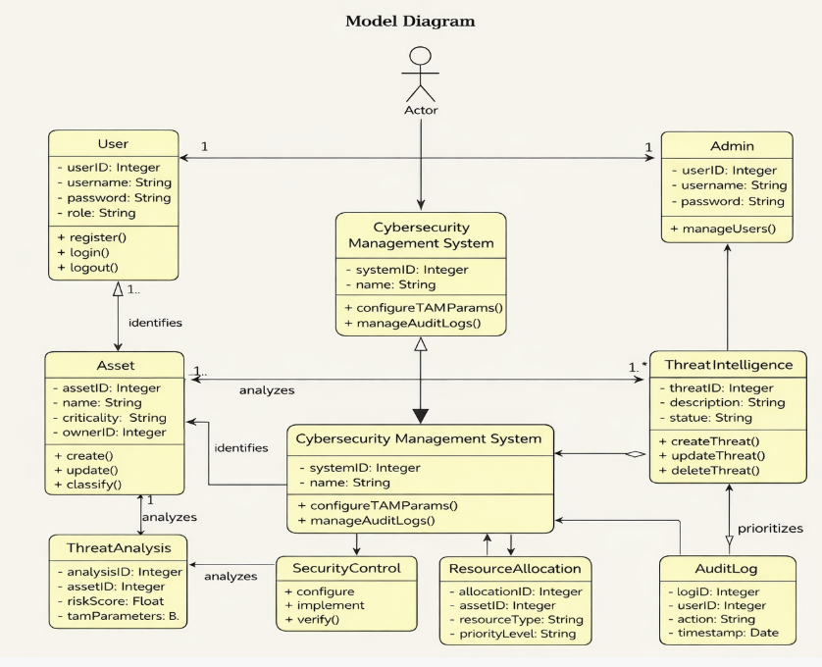

1.4. Overview
This paper is structured into several distinct sections to systematically achieve its research objectives. Following this introduction, Section 2 presents a comprehensive literature survey. This section will review the current landscape of cybersecurity standards and risk management approaches for NPPs, including NEI 13-10, IEC 62645, and guidance from the International Atomic Energy Agency (IAEA) . It will also delve into the details of the Technical Assessment Methodology (TAM), exploring its development by EPRI, its procedural steps (asset characterization, exploit sequence identification, control scoring, and target level setting), and its application in other critical infrastructure sectors . Furthermore, the literature survey will examine previous research on risk assessment for APR1400 I&C systems to establish a baseline for comparison . Section 3 will detail the research methodology, outlining the specific steps taken to apply NEI 13-10 and TAM to the plant protection system model. Section 4 will present the results of the comparative analysis, highlighting key differences in risk ratings and control effectiveness. Section 5 will provide a discussion of these findings, including the limitations of TAM and practical considerations for its implementation. Finally, Section 6 will conclude the paper and offer recommendations for future research.

2. Literature Survey
The digitalization of Nuclear Power Plant (NPP) Instrumentation and Control (I&C) systems, while enhancing performance and reliability, has introduced significant cybersecurity vulnerabilities. This literature survey reviews the existing body of knowledge concerning cybersecurity risk management in NPPs, the prevailing standards and methodologies, and the specific techniques proposed to enhance the security of critical systems like those in the APR1400.
2.1. Cybersecurity Risk Management in Nuclear Power Plants
The increasing reliance on digital technology in NPP I&C systems has made cybersecurity a critical issue. Unlike their analog predecessors, digital devices and networks are susceptible to a range of cyber attacks that could compromise safety and availability . The International Atomic Energy Agency (IAEA) has been at the forefront of addressing this, publishing guidance such as Nuclear Security Series (NSS) 17-T and NSS 33-T, which propose a comprehensive framework for computer security risk management at both the facility and individual system levels . These international efforts emphasize a risk-based approach, moving beyond simple checklists to a dynamic process of identifying, analyzing, and evaluating risks throughout the system lifecycle.
2.2. Standards and Compliance Frameworks: NEI 13-10 and IEC
Industry standards provide the foundational requirements for NPP cybersecurity. In the United States, NEI 13-10, "Cyber Security Control Assessments," serves as a key guideline for implementing the cybersecurity requirements of regulatory authorities . It provides a structured set of controls tailored to the unique characteristics of NPP assets, allowing for a differential application of security measures. On an international level, the IEC 62645 standard provides a framework for cybersecurity programs for I&C programmable systems . It introduces the concept of "security degrees" (SD) assigned to I&C systems based on their safety categorization, which then dictates the cybersecurity requirements. However, a recognized limitation of both NEI 13-10 and the earlier versions of IEC 62645 is that they offer limited detailed guidance on the process of risk management itself. They often reference ISO/IEC 27005 for risk assessment but leave the specific implementation methodology up to the organization . This creates a gap between compliance and the practical, continuous management of evolving cyber threats. The recently published IEC/TR 63486:2024 aims to address this by capturing and summarizing national and international cyber-risk approaches currently in use by NPP operators, providing a more practical toolkit for managing cybersecurity risks .
2.3. The EPRI Technical Assessment Methodology (TAM)
To bridge the gap between compliance and effectiveness, the Electric Power Research Institute (EPRI) developed the Technical Assessment Methodology (TAM) . TAM is a performance-based methodology designed to evaluate the sufficiency of cybersecurity controls on a specific asset against potential cyber attacks . It is not a replacement for standards like NEI 13-10 but rather a complementary tool to assess their effective implementation. The methodology, as detailed in Korean academic literature, involves a three-step process :
- Attack Surface Characterization: The target asset is analyzed and decomposed to understand its components, functions, and data flows. This step aims to identify potential "exploit sequences," which are pathways an attacker could use to compromise the system.
- Control Identification and Scoring: For each identified exploit sequence, applicable security controls are identified and assigned a score based on their effectiveness. A "target level" is then set, representing the minimum security score required to mitigate the risk associated with that exploit sequence, taking into account the potential consequences of a successful attack.
- Shared Control Analysis: If an exploit sequence cannot be fully mitigated by controls directly applied to the asset, this step analyzes "shared controls" or compensatory measures within a group of related assets (a "relationship set") to further reduce the residual risk .
TAM's strength lies in its quantitative and structured approach, forcing analysts to consider not just if a control is present, but how effective it is in the context of a specific threat. Its practical application is evidenced by its use in major projects, such as the cybersecurity assessment for the Barakah nuclear power plant in the UAE , and its proposed use for evaluating the security of other critical infrastructure components like solar inverters .
2.4. Cybersecurity Research on the APR1400
The APR1400, a Korean standard nuclear power plant, has been a focal point for I&C and cybersecurity research. Its digital I&C system, including the Reactor Protection System (RPS), has been developed through projects like KINCS (Korea Nuclear Instrumentation & Control System) . Researchers have proposed and applied various risk assessment processes to the APR1400's RPS, evaluating threats against its nodes and interfaces to derive risk ratings . These studies highlight the importance of analyzing specific system architectures to understand unique vulnerabilities. For instance, the APR1400 employs a strong security architecture that includes electrical isolation and physical separation between safety and non-safety networks, coupled with unidirectional data diode technology to protect safety systems . This architectural feature is a critical security control that any assessment methodology must account for. Recent research has also explored improving the efficiency of risk analysis for safety-critical assets (Type A1) in Korean NPPs by integrating methods like the Maintenance Rule (MR) with EPRI's TAM, aiming to re-analyze the impact of cyber intrusions on asset functionality and optimize the allocation of limited security manpower . This demonstrates a growing interest in moving beyond static compliance towards more dynamic and effective risk management strategies for the APR1400 and similar reactor designs.

3.SYSTEM ANALYSIS
3.1 Existing System and Disadvantages
Industrial control systems, such as nuclear power plants (NPPs), are increasingly exposed to cyber threats that can lead to serious economic losses and even human fatalities. NPPs, in turn, historically adopt differential application of cybersecurity controls depending on NEI 13-10 (Cyber Security Control Assessments). As much as NEI 13-10 offers a formalized method for applying controls based on plant-specific attributes, it has significant limitations. In particular, it fails to ensure sufficient consideration of new and developing cyber threats and also lacks a means of quantitatively confirming whether the implemented controls reduce the risks sufficiently. Additionally, due to limited protection resources for information, it is generally difficult to implement all required controls uniformly across all NPP assets.

Disadvantages of the Existing System:-

- NEI 13-10 fails to exhibit current and state-of-the-art cyber threats.

- Lack of quantitative confirmation of whether implemented controls reduce risks.

- Dependent on static, differential application of controls that can ignore changing vulnerabilities.

- Insufficient information protection resources to deploy all control requirements uniformly.

- Ineffective allocation of security measures among critical NPP assets.

3.2 PROBLEM STATEMENT
The rapid digitalization of healthcare systems has significantly increased the creation, storage, and sharing of medical images such as X-rays, MRI scans, CT scans, and ultrasound images. These images are frequently transmitted across hospitals, diagnostic centers, and research institutions for consultation, diagnosis, and collaborative analysis. While this digital transformation improves efficiency and accessibility, it also introduces serious security and privacy challenges.
Medical images contain highly sensitive patient information, and any unauthorized access, tampering, or leakage can lead to severe consequences, including privacy violations, misdiagnosis, legal liabilities, and loss of trust in healthcare systems. Existing medical image sharing systems primarily rely on traditional centralized security techniques such as encryption and basic watermarking. Although encryption ensures confidentiality during transmission, it does not provide protection once the image is decrypted at the receiver’s end. After decryption, the image becomes vulnerable to unauthorized copying, modification, redistribution, and misuse.
Furthermore, current systems often lack effective mechanisms for:
- Detecting image tampering after sharing
- Ensuring traceability of image access and usage
- Maintaining persistent linkage between patient metadata and image content
- Providing secure collaboration across multiple healthcare institutions
Traditional watermarking techniques offer authentication and ownership verification but may compromise image quality or fail to withstand advanced image processing attacks. Additionally, centralized storage systems create single points of failure, making them attractive targets for cyber-attacks.
Another critical issue is the need for collaborative AI-based medical analysis without compromising patient privacy. Centralized AI model training requires aggregation of large datasets from multiple institutions, which increases the risk of data breaches and regulatory non-compliance.
Therefore, there is a need for a comprehensive, hybrid security framework that:
- Ensures confidentiality, integrity, and authenticity of medical images
- Provides tamper detection and traceability mechanisms
- Preserves diagnostic image quality
- Enables privacy-preserving collaborative AI training
- Complies with healthcare data protection regulations
The problem addressed in this project is the lack of an integrated secure medical image sharing system that combines AI-driven watermarking, blockchain-based traceability, federated learning, and strong access control mechanisms to provide persistent, tamper-proof, and privacy-preserving protection for medical images.
The objective is to design and develop a robust system architecture that overcomes the limitations of existing approaches while maintaining efficiency, scalability, and regulatory compliance.

3.3 Proposed System and Advantages
As a solution for these limitations, the Technical Assessment Methodology (TAM) proposed by the Electric Power Research Institute (ETRI) is presented. TAM facilitates quantitative assessment of cybersecurity through the production of a score that indicates the performance of security controls against possible cyber-attacks on identified NPP assets. Through the integration of NEI 13-10 and TAM, differential controls can be implemented more efficiently so that limited resources will be assigned to the most important areas. In contrast to the conventional methods, this combined approach confirms if security controls indeed reduce risks and is data-driven for ongoing improvement. In the example of the APR1400 reactor plant protection system, this comparative analysis proved that the integration of NEI 13-10 with TAM results in more accurate and effective risk reduction than using NEI 13-10.

Benefits of the Proposed System:-

- Offers a quantitative scoring system to quantify control effectiveness.

- Improves NEI 13-10 by taking into account changing and sophisticated cyber threats.

- Facilitates evidence-based decision-making in allocating resources.

- Verifies if implemented controls indeed reduce risks.

- Enables customized and effective deployment of cybersecurity controls on NPP assets.

- Enhances resilience of important plant systems (e.g., APR1400 plant protection system).

System Architecture
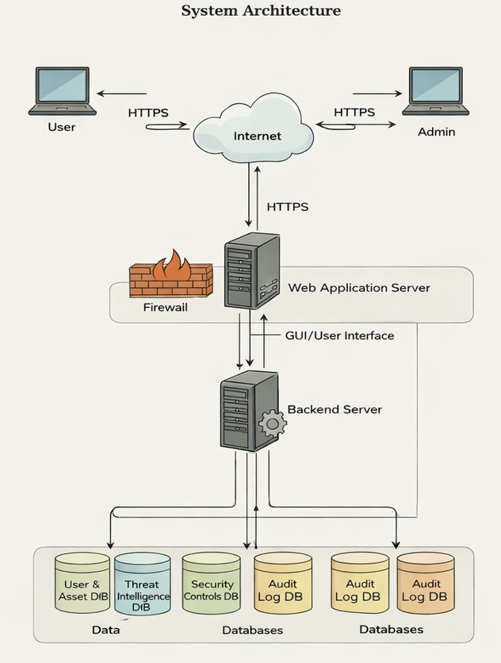

Module Description:-

- Threat Analysis Module

- Detects possible cyber-attacks on NPP systems, targeting emerging and high-impact threats.

- Control Assessment Module (NEI 13-10)

- Implements baseline differential security controls based on plant-specific features.

- Technical Assessment Methodology (TAM) Module

- Calculates quantitative risk scores by reviewing the efficacy of security controls against threats.

- Risk Mitigation Verification Module

- Verifies whether implemented controls effectively minimize recognized risks.

- Resource Allocation Module

- Orders and assigns scarce information protection resources based on TAM scores and asset criticality.

- Comparative Analysis Module

- Compares results from single-use of NEI 13-10 against combined NEI 13-10 + TAM (e.g., in APR1400).

- Future Research & Improvement Module

- Recognizes TAM limitations and suggests improvements for wider applicability across various NPP systems.

4. SYSTEM REQUIREMENTS SPECIFICATION
System Requirements Specification (SRS) defines the functional and non-functional requirements of the Cyber Security Nuclear plant.
4.1 Functional Requirements
User Module
- The system shall allow new users to create an account using unique credentials.
- The system shall allow registered users to log in and log out securely.
- The system shall restrict access to features based on assigned roles.
- The system shall allow users to identify, register, and update asset information.
- The system shall allow users to classify assets based on predefined criticality levels.
- The system shall allow users to identify threat scenarios related to selected assets.
- The system shall perform risk analysis based on defined assessment parameters.
- The system shall generate risk scores using configured scoring models.
- The system shall display risk assessment results to users.
- The system shall allow users to view recommended security controls.
- The system shall allow users to implement and update security control status.
- The system shall allow users to verify mitigation effectiveness.
- The system shall allow users to compare risk levels before and after mitigation.
- The system shall allow users to generate risk assessment reports.
- The system shall log user activities for monitoring purposes.

Admin Module
- The system shall allow administrators to log in securely.
- The system shall allow administrators to manage user accounts.
- The system shall allow administrators to assign and manage user roles and permissions.
- The system shall allow administrators to manage threat intelligence records.
- The system shall allow administrators to configure risk assessment parameters and scoring weights.
- The system shall allow administrators to configure and manage security control settings.
- The system shall allow administrators to define asset classification categories.
- The system shall allow administrators to prioritize assets based on calculated risk scores.
- The system shall allow administrators to manage resource allocation based on risk severity.
- The system shall allow administrators to access audit logs.
- The system shall allow administrators to generate compliance and monitoring reports.
- The system shall provide system monitoring dashboards for administrators.

4.2 Non-Functional Requirements
Non-functional requirements define the quality attributes of the system.
User Module
- The system shall ensure secure authentication using encrypted passwords.
- The system shall use secure communication protocols for data transmission.
- The system shall provide a user-friendly and intuitive interface.
- The system shall respond to user actions within acceptable performance limits.
- The system shall ensure high availability for user operations.
- The system shall protect user data through regular backups.
- The system shall prevent unauthorized access to restricted features.

Admin Module
- The system shall enforce strong authentication mechanisms for administrative access.
- The system shall maintain detailed logs of administrative actions.
- The system shall ensure system availability and reliability for administrative operations.
- The system shall support scalability for increasing users and data volume.
- The system shall allow configuration changes without full system downtime.
- The system shall retain audit logs for a defined compliance period.
- The system shall ensure data integrity and consistency across modules.

4.3 Hardware Requirements
- Minimum Intel i5 Processor or higher
- Minimum 6 GB RAM
- 500 GB Hard Disk (or scalable cloud storage)
- GPU (Optional – recommended for AI watermarking models)

4.4 Software Requirements
- Operating System: Windows / Linux
- Programming Language: Python
- AI Libraries:
  - TensorFlow
  - PyTorch
  - Scikit-learn
- Blockchain Framework (e.g., Ethereum / Hyperledger – optional implementation)
- Web Technologies:
  - HTML
  - CSS
  - JavaScript
  - Flask / Django (Backend Framework)
- Database:
  - MySQL / PostgreSQL

5. SYSTEM DESIGN

5.1 System Environment
What is Python :
Below are some facts about Python.
Python is currently the most widely used multi-purpose, high-level programming language.
Python allows programming in Object-Oriented and Procedural paradigms. Python programs generally are smaller than other programming languages like Java.
Programmers have to type relatively less and indentation requirement of the language, makes them readable all the time.
Python language is being used by almost all tech-giant companies like – Google, Amazon, Facebook, Instagram, Dropbox, Uber… etc.
The biggest strength of Python is huge collection of standard library which can be used for the following –

- Machine Learning
- GUI Applications (like Kivy, Tkinter, PyQt etc. )
- Web frameworks like Django (used by YouTube, Instagram, Dropbox)
- Image processing (like Opencv, Pillow)
- Web scraping (like Scrapy, BeautifulSoup, Selenium)
- Test frameworks
- Multimedia
What is Machine Learning : -
Before we take a look at the details of various machine learning methods, let's start by looking at what machine learning is, and what it isn't. Machine learning is often categorized as a subfield of artificial intelligence, but I find that categorization can often be misleading at first brush. The study of machine learning certainly arose from research in this context, but in the data science application of machine learning methods, it's more helpful to think of machine learning as a means of building models of data.
Fundamentally, machine learning involves building mathematical models to help understand data. "Learning" enters the fray when we give these models tunable parameters that can be adapted to observed data; in this way the program can be considered to be "learning" from the data. Once these models have been fit to previously seen data, they can be used to predict and understand aspects of newly observed data. I'll leave to the reader the more philosophical digression regarding the extent 28
to which this type of mathematical, model-based "learning" is similar to the "learning" exhibited by the human brain.Understanding the problem setting in machine learning is essential to using these tools effectively, and so we will start with some broad categorizations of the types of approaches we'll discuss here.
Types of Machine Learning
- Supervised Learning – This involves learning from a training dataset with labeled data using classification and regression models. This learning process continues until the required level of performance is achieved.
- Unsupervised Learning – This involves using unlabelled data and then finding the underlying structure in the data in order to learn more and more about the data itself using factor and cluster analysis models.
- Semi-supervised Learning – This involves using unlabelled data like Unsupervised Learning with a small amount of labeled data. Using labeled data vastly increases the learning accuracy and is also more cost-effective than Supervised Learning.
Reinforcement Learning – This involves learning optimal actions through trial and error. So the next action is decided by learning behaviors that are based on the current state and that will maximize the reward in the future.
Python
Python is an interpreted high-level programming language for general-purpose programming. Created by Guido van Rossum and first released in 1991, Python has a design philosophy that emphasizes code readability, notably using significant whitespace.
Python features a dynamic type system and automatic memory management. It supports multiple programming paradigms, including object-oriented, imperative, functional and procedural, and has a large and comprehensive standard library.
• Python is Interpreted − Python is processed at runtime by the interpreter. You do not need to compile your program before executing it. This is similar to PERL and PHP.
• Python is Interactive − you can actually sit at a Python prompt and interact with the interpreter directly to write your programs.

Python also acknowledges that speed of development is important. Readable and terse code is part of this, and so is access to powerful constructs that avoid tedious repetition of code. Maintainability also ties into this may be an all but useless metric, but it does say something about how much code you have to scan, read and/or understand to troubleshoot problems or tweak behaviors. This speed 36
of development, the ease with which a programmer of other languages can pick up basic Python skills and the huge standard library is key to another area where Python excels. All its tools have been quick to implement, saved a lot of time, and several of them have later been patched and updated by people with no Python background - without breaking.
Modules Used in Project :-
Tensorflow
TensorFlow is a free and open-source software library for dataflow and differentiable programming across a range of tasks. It is a symbolic math library, and is also used for machine learning applications such as neural networks. It is used for both research and production at Google.
TensorFlow was developed by the Google Brain team for internal Google use. It was released under the Apache 2.0 open-source license on November 9, 2015.
Numpy
Numpy is a general-purpose array-processing package. It provides a high-performance multidimensional array object, and tools for working with these arrays.
It is the fundamental package for scientific computing with Python. It contains various features including these important ones:
- A powerful N-dimensional array object
- Sophisticated (broadcasting) functions
- Tools for integrating C/C++ and Fortran code
- Useful linear algebra, Fourier transform, and random number capabilities
Besides its obvious scientific uses, Numpy can also be used as an efficient multi-dimensional container of generic data. Arbitrary data-types can be defined using Numpy which allows Numpy to seamlessly and speedily integrate with a wide variety of databases.
Pandas
Pandas is an open-source Python Library providing high-performance data manipulation and analysis tool using its powerful data structures. Python was majorly used for data munging and preparation. It had very little contribution towards data analysis. Pandas solved this problem. Using Pandas, we can accomplish five typical steps in the processing and analysis of data, regardless of the origin of data load, prepare, manipulate, model, and analyze. Python with Pandas is used in a 37

wide range of fields including academic and commercial domains including finance, economics, Statistics, analytics, etc.
Matplotlib
Matplotlib is a Python 2D plotting library which produces publication quality figures in a variety of hardcopy formats and interactive environments across platforms. Matplotlib can be used in Python scripts, the Python and IPython shells, the Jupyter Notebook, web application servers, and four graphical user interface toolkits. Matplotlib tries to make easy things easy and hard things possible. You can generate plots, histograms, power spectra, bar charts, error charts, scatter plots, etc., with just a few lines of code. For examples, see the sample plots and thumbnail gallery.
For simple plotting the pyplot module provides a MATLAB-like interface, particularly when combined with IPython. For the power user, you have full control of line styles, font properties, axes properties, etc, via an object oriented interface or via a set of functions familiar to MATLAB users.
Scikit – learn
Scikit-learn provides a range of supervised and unsupervised learning algorithms via a consistent interface in Python. It is licensed under a permissive simplified BSD license and is distributed under many Linux distributions, encouraging academic and commercial use. Python
Python is an interpreted high-level programming language for general-purpose programming. Created by Guido van Rossum and first released in 1991, Python has a design philosophy that emphasizes code readability, notably using significant whitespace.
Python features a dynamic type system and automatic memory management. It supports multiple programming paradigms, including object-oriented, imperative, functional and procedural, and has a large and comprehensive standard library.
- Python is Interpreted − Python is processed at runtime by the interpreter. You do not need to compile your program before executing it. This is similar to PERL and PHP.
- Python is Interactive − you can actually sit at a Python prompt and interact with the interpreter directly to write your programs.

Python also acknowledges that speed of development is important. Readable and terse code is part of this, and so is access to powerful constructs that avoid tedious repetition of code. Maintainability also ties into this may be an all but useless metric, but it does say something about how much code you have to scan, read and/or understand to troubleshoot problems or tweak behaviors. This speed of development, the ease with which a programmer of other languages can pick up basic Python 38

skills and the huge standard library is key to another area where Python excels. All its tools have been quick to implement, saved a lot of time, and several of them have later been patched and updated by people with no Python background - without breaking.

5.2 Data Flow Diagram (DFD)
- The DFD is also called as bubble chart. It is a simple graphical formalism that can be used to represent a system in terms of input data to the system, various processing carried out on this data, and the output data is generated by this system.
- The data flow diagram (DFD) is one of the most important modeling tools. It is used to model the system components. These components are the system process, the data used by the process, an external entity that interacts with the system and the information flows in the system.
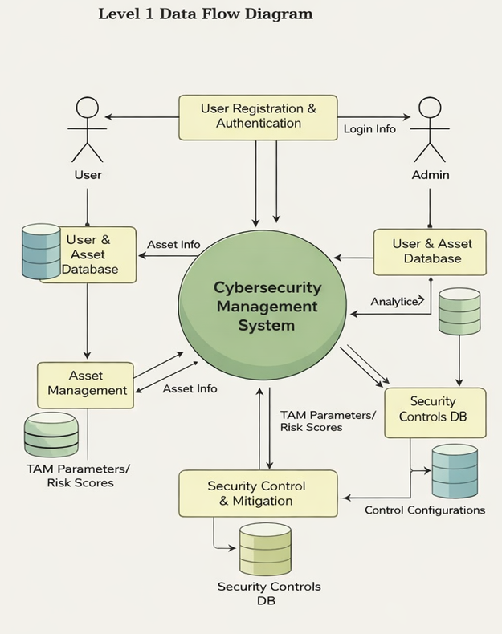

5.3 UML Diagrams
UML stands for Unified Modeling Language. UML is a standardized general-purpose modeling language in the field of object-oriented software engineering. The standard is managed, and was created by, the Object Management Group.
The goal is for UML to become a common language for creating models of object oriented computer software. In its current form UML is comprised of two major components: a Meta-model and a notation. In the future, some form of method or process may also be added to; or associated with, UML.
The Unified Modeling Language is a standard language for specifying, Visualization, Constructing and documenting the artifacts of software system, as well as for business modeling and other non-software systems.
The UML represents a collection of best engineering practices that have proven successful in the modeling of large and complex systems.
The UML is a very important part of developing objects oriented software and the software development process. The UML uses mostly graphical notations to express the design of software projects.

GOALS:
The Primary goals in the design of the UML are as follows:
- Provide users a ready-to-use, expressive visual modeling Language so that they can develop and exchange meaningful models.
- Provide extendibility and specialization mechanisms to extend the core concepts.
- Be independent of particular programming languages and development process.
- Provide a formal basis for understanding the modeling language.
- Encourage the growth of OO tools market.
- Support higher level development concepts such as collaborations, frameworks, patterns and components.
- Integrate best practices.

USE CASE DIAGRAM:
A use case diagram in the Unified Modeling Language (UML) is a type of behavioral diagram defined by and created from a Use-case analysis. Its purpose is to present a graphical overview of the functionality provided by a system in terms of actors, their goals (represented as use cases), and any dependencies between those use cases. The main purpose of a use case diagram is to show what system functions are performed for which actor. Roles of the actors in the system can be depicted.
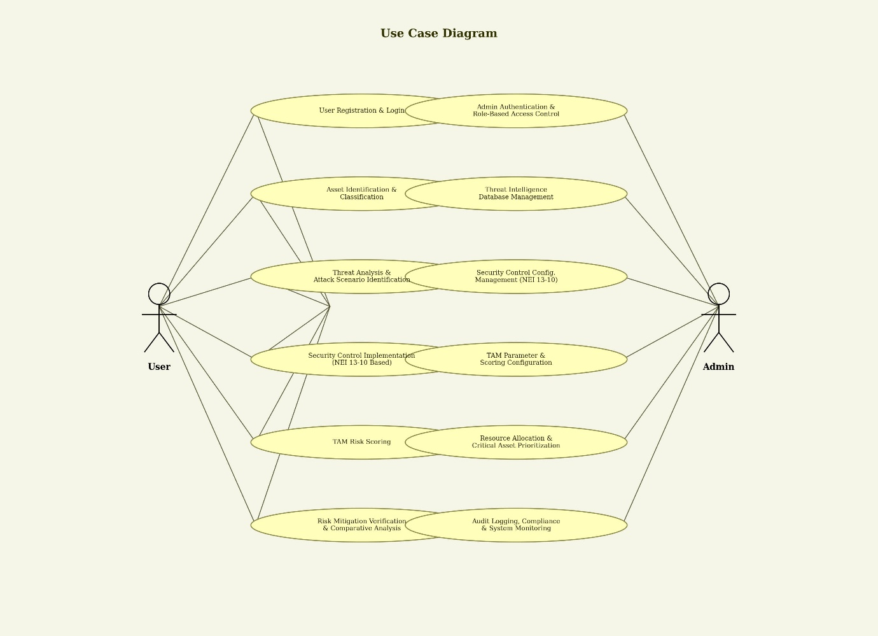

Class Diagram
In software engineering, a class diagram in the Unified Modeling Language (UML) is a type of static structure diagram that describes the structure of a system by showing the system's classes, their attributes, operations (or methods), and the relationships among the classes. It explains which class contains information.

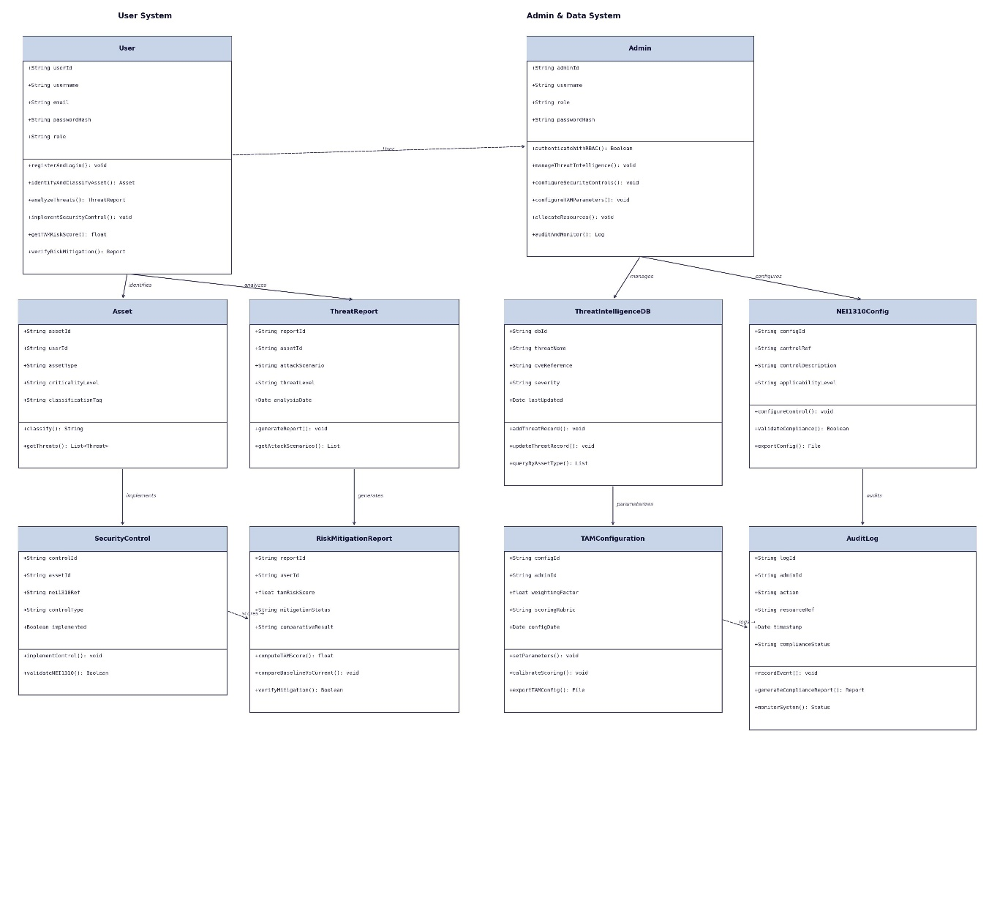
Sequence Diagram
A sequence diagram in Unified Modeling Language (UML) is a kind of interaction diagram that shows how processes operate with one another and in what order. It is a construct of a Message Sequence Chart. Sequence diagrams are sometimes called event diagrams, event scenarios, and timing diagrams.

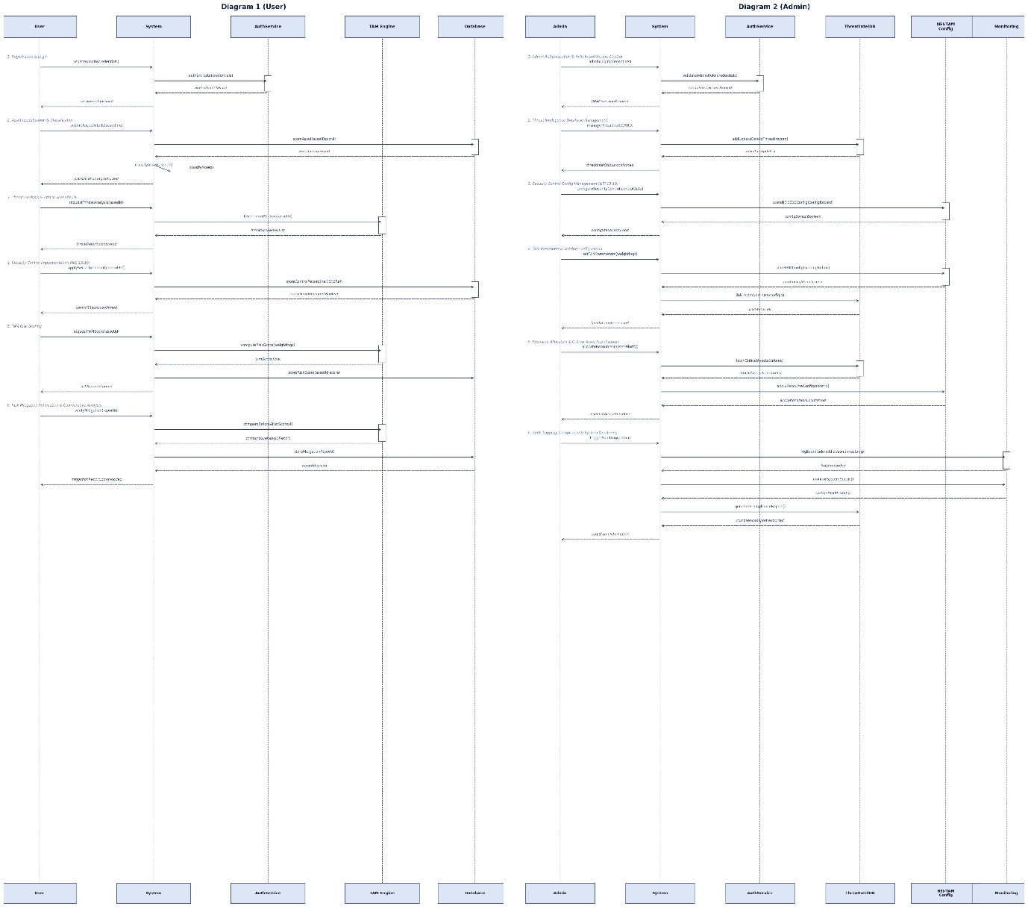

Activity Diagram
Activity diagrams are graphical representations of workflows of stepwise activities and actions with support for choice, iteration and concurrency. In the Unified Modeling Language, activity diagrams can be used to describe the business and operational step-by-step workflows of components in a system. An activity diagram shows the overall flow of control.
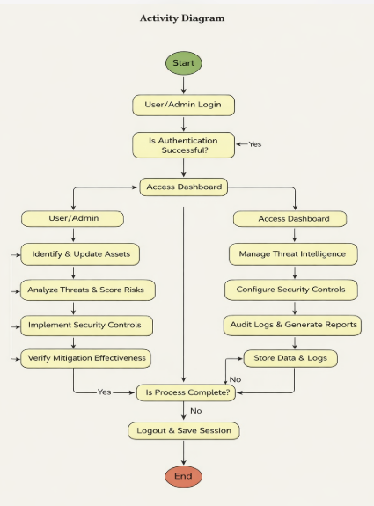

6. Implementation
6.1 Sample code

7. SYSTEM TESTING
System testing is conducted to ensure that the Secure Medical Image Sharing System functions correctly, securely, and efficiently according to the specified requirements. Testing verifies whether each module operates as intended and whether the integrated system meets security, performance, reliability, and compliance standards.
Testing is performed at multiple levels including unit testing, integration testing, system testing, user acceptance testing, performance testing, and security testing.
7.1 Types of Testing
System Testing
Types of Software Testing: Different Testing Types with Details
We, as testers, are aware of the various types of Software Testing like Functional Testing, Non-Functional Testing, Automation Testing, Agile Testing, and their sub-types, etc.
Each type of testing has its own features, advantages, and disadvantages as well. However, in this tutorial, we have covered mostly each and every type of software testing which we usually use in our day-to-day testing life.
Different Types of Software Testing
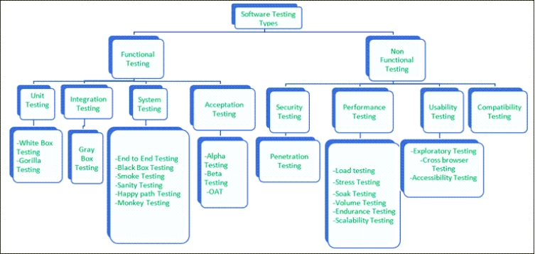

Functional Testing
There are four main types of functional testing.
#1) Unit Testing
Unit testing is a type of software testing which is done on an individual unit or component to test its corrections. Typically, Unit testing is done by the developer at the application development phase. Each unit in unit testing can be viewed as a method, function, procedure, or object. Developers often use test automation tools such as NUnit, Xunit, JUnit for the test execution.
Unit testing is important because we can find more defects at the unit test level.
For example, there is a simple calculator application. The developer can write the unit test to check if the user can enter two numbers and get the correct sum for addition functionality.
a) White Box Testing
White box testing is a test technique in which the internal structure or code of an application is visible and accessible to the tester. In this technique, it is easy to find loopholes in the design of an application or fault in business logic. Statement coverage and decision coverage/branch coverage are examples of white box test techniques.
b) Gorilla Testing
Gorilla testing is a test technique in which the tester and/or developer test the module of the application thoroughly in all aspects. Gorilla testing is done to check how robust your application is.
For example, the tester is testing the pet insurance company’s website, which provides the service of buying an insurance policy, tag for the pet, Lifetime membership. The tester can focus on any one module, let’s say, the insurance policy module, and test it thoroughly with positive and negative test scenarios.
#2) Integration Testing
Integration testing is a type of software testing where two or more modules of an application are logically grouped together and tested as a whole. The focus of this type of testing is to find the defect on interface, communication, and data flow among modules. Top-down or Bottom-up approach is used while integrating modules into the whole system.
This type of testing is done on integrating modules of a system or between systems. For example, a user is buying a flight ticket from any airline website. Users can see flight details and payment information while buying a ticket, but flight details and payment processing are two different systems. Integration testing should be done while integrating of airline website and payment processing system.
a) Gray box testing
As the name suggests, gray box testing is a combination of white-box testing and black-box testing. Testers have partial knowledge of the internal structure or code of an application.
#3) System Testing
System testing is types of testing where tester evaluates the whole system against the specified requirements.
a) End to End Testing
It involves testing a complete application environment in a situation that mimics real-world use, such as interacting with a database, using network communications, or interacting with other hardware, applications, or systems if appropriate.
For example, a tester is testing a pet insurance website. End to End testing involves testing of buying an insurance policy, LPM, tag, adding another pet, updating credit card information on users’ accounts, updating user address information, receiving order confirmation emails and policy documents.
b) Black Box Testing
Blackbox testing is a software testing technique in which testing is performed without knowing the internal structure, design, or code of a system under test. Testers should focus only on the input and output of test objects.
Detailed information about the advantages, disadvantages, and types of Black Box testing can be found here.
c) Smoke Testing
Smoke testing is performed to verify that basic and critical functionality of the system under test is working fine at a very high level.
Whenever a new build is provided by the development team, then the Software Testing team validates the build and ensures that no major issue exists. The testing team will ensure that the build is stable, and a detailed level of testing will be carried out further.
For example, tester is testing pet insurance website. Buying an insurance policy, adding another pet, providing quotes are all basic and critical functionality of the application. Smoke testing for this website verifies that all these functionalities are working fine before doing any in-depth testing.
d) Sanity Testing
Sanity testing is performed on a system to verify that newly added functionality or bug fixes are working fine. Sanity testing is done on stable build. It is a subset of the regression test.
For example, a tester is testing a pet insurance website. There is a change in the discount for buying a policy for second pet. Then sanity testing is only performed on buying insurance policy module.
e) Happy path Testing
The objective of Happy Path Testing is to test an application successfully on a positive flow. It does not look for negative or error conditions. The focus is only on valid and positive inputs through which the application generates the expected output.
f) Monkey Testing
Monkey Testing is carried out by a tester, assuming that if the monkey uses the application, then how random input and values will be entered by the Monkey without any knowledge or understanding of the application.
The objective of Monkey Testing is to check if an application or system gets crashed by providing random input values/data. Monkey Testing is performed randomly, no test cases are scripted, and it is not necessary to be aware
of the full functionality of the system.
#4) Acceptance Testing
Acceptance testing is a type of testing where client/business/customer test the software with real time business scenarios.
The client accepts the software only when all the features and functionalities work as expected. This is the last phase of testing, after which the software goes into production. This is also called User Acceptance Testing (UAT).
a) Alpha Testing
Alpha testing is a type of acceptance testing performed by the team in an organization to find as many defects as possible before releasing software to customers.
For example, the pet insurance website is under UAT. UAT team will run real-time scenarios like buying an insurance policy, buying annual membership, changing the address, ownership transfer of the pet in a same way the user uses the real website. The team can use test credit card information to process payment-related scenarios.
b) Beta Testing
Beta Testing is a type of software testing which is carried out by the clients/customers. It is performed in the Real Environment before releasing the product to the market for the actual end-users.
Beta Testing is carried out to ensure that there are no major failures in the software or product, and it satisfies the business requirements from an end-user perspective. Beta Testing is successful when the customer accepts the software.
Usually, this testing is typically done by the end-users. This is the final testing done before releasing the application for commercial purposes. Usually, the Beta version of the software or product released is limited to a certain number of users in a specific area.
So, the end-user uses the software and shares the feedback with the company. The company then takes necessary action before releasing the software worldwide.
c) Operational acceptance testing (OAT)
Operational acceptance testing of the system is performed by operations or system administration staff in the production environment. The purpose of operational acceptance testing is to make sure that the system administrators can keep the system working properly for the users in a real-time environment.
The focus of the OAT is on the following points:
- Testing of backup and restore.
- Installing, uninstalling, upgrading software.
- The recovery process in case of natural disaster.
- User management.
- Maintenance of the software.

Non-Functional Testing
There are four main types of functional testing.
#1) Security Testing
It is a type of testing performed by a special team. Any hacking method can penetrate the system.
Security Testing is done to check how the software, application, or website is secure from internal and/or external threats. This testing includes how much software is secure from malicious programs, viruses and how secure & strong the authorization and authentication processes are.
It also checks how software behaves for any hacker’s attack & malicious programs and how software is maintained for data security after such a hacker attack.
a) Penetration Testing
Penetration Testing or Pen testing is the type of security testing performed as an authorized cyberattack on the system to find out the weak points of the system in terms of security.
Pen testing is performed by outside contractors, generally known as ethical hackers. That is why it is also known as ethical hacking. Contractors perform different operations like SQL injection, URL manipulation, Privilege Elevation, session expiry, and provide reports to the organization.
Notes: Do not perform the Pen testing on your laptop/computer. Always take written permission to do pen tests.
#2) Performance Testing
Performance testing is testing of an application’s stability and response time by applying load.
The word stability means the ability of the application to withstand in the presence of load. Response time is how quickly an application is available to users. Performance testing is done with the help of tools. Loader.IO, JMeter, LoadRunner, etc. are good tools available in the market.
a) Load testing
Load testing is testing of an application’s stability and response time by applying load, which is equal to or less than the designed number of users for an application.
For example, your application handles 100 users at a time with a response time of 3 seconds, then load testing can be done by applying a load of the maximum of 100 or less than 100 users. The goal is to verify that the application is responding within 3 seconds for all the users.
b) Stress Testing
Stress testing is testing an application’s stability and response time by applying load, which is more than the designed number of users for an application.
For example, your application handles 1000 users at a time with a response time of 4 seconds, then stress testing can be done by applying a load of more than 1000 users. Test the application with 1100,1200,1300 users and notice the response time. The goal is to verify the stability of an application under stress.
c) Scalability Testing
Scalability testing is testing an application’s stability and response time by applying load, which is more than the designed number of users for an application.
For example, your application handles 1000 users at a time with a response time of 2 seconds, then scalability testing can be done by applying a load of more than 1000 users and gradually increasing the number of users to find out where exactly my application is crashing.
Let’s say my application is giving response time as follows:
- 1000 users -2 sec
- 1400 users -2 sec
- 4000 users -3 sec
- 5000 users -45 sec
- 5150 users- crash – This is the point that needs to identify in scalability testing
d) Volume testing (flood testing)
Volume testing is testing an application’s stability and response time by transferring a large volume of data to the database. Basically, it tests the capacity of the database to handle the data.
e) Endurance Testing (Soak Testing)
Endurance testing is testing an application’s stability and response time by applying load continuously for a longer period to verify that the application is working fine.
For example, car companies soak testing to verify that users can drive cars continuously for hours without any problem.
#3) Usability Testing
Usability testing is testing an application from the user’s perspective to check the look and feel and user-friendliness.
For example, there is a mobile app for stock trading, and a tester is performing usability testing. Testers can check the scenario like if the mobile app is easy to operate with one hand or not, scroll bar should be vertical, background colour of the app should be black and price of and stock is displayed in red or green colour.
The main idea of usability testing of this kind of app is that as soon as the user opens the app, the user should get a glance at the market.
a) Exploratory testing
Exploratory Testing is informal testing performed by the testing team. The objective of this testing is to explore the application and look for defects that exist in the application. Testers use the knowledge of the business domain to test the application. Test charters are used to guide the exploratory testing.
b) Cross browser testing
Cross browser testing is testing an application on different browsers, operating systems, mobile devices to see look and feel and performance.
Why do we need cross-browser testing? The answer is different users use different operating systems, different browsers, and different mobile devices. The goal of the company is to get a good user experience regardless of those devices.
Browser stack provides all the versions of all the browsers and all mobile devices to test the application. For learning purposes, it is good to take the free trial given by browser stack for a few days.
c) Accessibility Testing
The aim of Accessibility Testing is to determine whether the software or application is accessible for disabled people or not.
Here, disability means deafness, colour blindness, mentally disabled, blind, old age, and other disabled groups. Various checks are performed, such as font size for visually disabled, colour and contrast for colour blindness, etc.
#4) Compatibility testing
This is a testing type in which it validates how software behaves and runs in a different environment, web servers, hardware, and network environment.

7.3 Test Cases
TC ID | Test Case Description | Pre-Condition | Test Steps | Expected Result
TC-01 | Verify user registration | User not registered | Enter valid details → Submit | User account created successfully
TC-02 | Verify login with valid credentials | User registered | Enter username & password → Login | User redirected to dashboard
TC-03 | Verify login with invalid credentials | User registered | Enter wrong password → Login | Error message displayed
TC-04 | Verify Admin RBAC restrictions | Admin logged in | Access user-only feature | Access denied
TC-05 | Add new asset | User logged in | Navigate to Asset → Add asset details | Asset saved successfully
TC-06 | Perform threat analysis | Asset exists | Select asset → Identify threat → Run analysis | Risk score generated
TC-07 | Configure TAM parameters | Admin logged in | Modify scoring weight → Save | Parameters updated successfully
TC-08 | Implement security control | Threat identified | Select control → Mark implemented | Status updated
TC-09 | Verify audit logging | User performs action | Perform login or asset update | Activity recorded in audit log
TC-10 | Generate compliance report | Admin logged in | Click Generate Report | Report generated successfully

7.4 Discussion of Results(ScreenShots)

8. CONCLUSION AND FUTURE ENHANCEMENTS
8.1 Conclusion
This study has systematically addressed the critical challenge of implementing effective cybersecurity controls in Nuclear Power Plants (NPPs) under the constraint of limited information protection resources. The research demonstrates that while the traditional NEI 13-10 framework provides an essential baseline for identifying Critical Digital Assets (CDAs) and applying differential security controls based on consequence assessment, this checklist-based approach alone is insufficient for validating whether those controls actually mitigate emerging and sophisticated cyber threats .
The Technical Assessment Methodology (TAM), developed by the Electric Power Research Institute (ETRI), emerges as a powerful complementary framework that enables quantitative, effects-based cybersecurity assessment . By evaluating the potential impact of cyber attacks on assets and their associated security controls, TAM generates quantitative risk scores that provide a dynamic and verifiable measure of security posture. The comparative analysis conducted on the APR1400 reactor's plant protection system confirms that the combined application of NEI 13-10 and TAM yields superior risk insights compared to using NEI 13-10 alone .
The seven-module architecture presented—spanning Threat Analysis, Control Assessment (NEI 13-10), TAM Quantification, Risk Mitigation Verification, Resource Allocation, Comparative Analysis, and Future Research—provides a comprehensive framework for operationalizing this enhanced approach. This architecture successfully addresses the fundamental problem of resource optimization by enabling plant operators to prioritize remediation efforts based on actual risk to the plant rather than applying uniform controls across thousands of identified assets. As confirmed by recent Korean research, integrating TAM with maintenance perspectives allows for re-evaluating the impact of cyber intrusions on asset functionality, thereby reducing the burden on limited on-site cybersecurity personnel while strengthening overall security posture .
Furthermore, the study aligns with the latest international guidance, including IEC TR 63486:2024, which emphasizes the need for comprehensive cyber-risk approaches that address the 11 specific challenges to cybersecurity risk management in NPPs . The quantitative framework also resonates with contemporary research advocating for consequence-based classification and systematic evaluation of Security Control Measures (SCMs) against identified threat scenarios . In conclusion, the TAM-based methodology represents a significant advancement in nuclear cybersecurity, moving the industry from static compliance verification toward dynamic, risk-informed security management that demonstrably protects both digital infrastructure and physical reactor safety.

8.2 Future Enhancements
While the Technical Assessment Methodology (TAM) represents a significant advancement over traditional checklist-based approaches, several limitations and opportunities for future enhancement have been identified through this research:
1. Integration with Advanced Threat Detection Technologies
Future research should explore the integration of TAM with machine learning-based anomaly detection systems, such as FusionGuard, which has demonstrated proficiency in detecting ransomware and spyware intrusions within NPP networks with remarkable accuracy and minimal false positives . By incorporating real-time threat intelligence into the TAM quantification engine, the methodology could evolve from periodic assessment to continuous risk monitoring.
2. Expansion to Advanced Reactor Designs and Space Systems
As the nuclear energy landscape evolves toward small modular reactors (SMRs) and advanced reactor designs, TAM must be adapted to address unique architectural characteristics. Recent research on space nuclear reactor power systems has demonstrated the vulnerability of such systems to false data injection attacks (FDIAs) and the importance of programmable logic controllers in mitigating these effects . Future work should extend TAM to cover these emerging applications and their distinct threat vectors.
3. Incorporation of System-Theoretic Process Analysis (STPA)
Current TAM applications could be enhanced by integrating System-Theoretic Process Analysis (STPA) to identify system-level threat scenarios that could violate safety constraints . This approach would enable a more comprehensive analysis of cyber-physical interactions, moving beyond asset-focused assessment to consider entire system dynamics and interdependencies.
4. Development of Automated TAM Tools
The practical deployment of TAM across multiple NPPs will require the development of automated software tools that can streamline data collection, threat scenario modeling, and quantitative scoring. Such tools should incorporate user-friendly interfaces for plant operators and provide visual dashboards for tracking risk posture over time.
5. Integration with Digital Twin Technology
Emerging research on NPP digital twins for robotics and autonomous intelligence presents opportunities to validate TAM scores through simulated attack scenarios in high-fidelity virtual environments. Hardware-in-the-loop testbeds using full-scope simulators could provide experimental validation of TAM predictions and enable refinement of the quantitative models .
6. Enhancement of the Resource Allocation Module
The Resource Allocation Module could be further refined by incorporating multi-objective optimization algorithms that balance risk reduction against implementation costs, personnel availability, and regulatory deadlines. This would transform the current prioritization scheme into a true decision support system for plant management.
7. Cross-Industry Benchmarking and Standardization
Future work should establish benchmarking datasets and standardized evaluation criteria for comparing TAM applications across different NPP designs and potentially other critical infrastructure sectors. This would facilitate regulatory acceptance and promote harmonization with international standards such as IEC TR 63486 and ISO/IEC 27005 .

9.REFERENCES
- [1] Improving the Efficiency of Cybersecurity Risk Analysis Methods for Nuclear Power Plant Control Systems, Journal of the Korea Institute of Information Security & Cryptology, 2024, pp. 537-552
- [2] IEC TR 63486:2024, Nuclear facilities - Instrumentation, control and electrical power systems - Cybersecurity risk management approaches, International Electrotechnical Commission, September 2024
- [3] K.-S. Son, J.-G. Song, and J.-W. Lee, "Development of the framework for quantitative cyber risk assessment in nuclear facilities," Nuclear Engineering and Technology, vol. 55, no. 6, pp. 2034-2046, June 2023
- [4] A. H. N. Almoqbil, "Anomaly detection for early ransomware and spyware warning in nuclear power plant systems based on FusionGuard," International Journal of Information Security, 2024
- [5] D. Jung, J. Shin, C. Lee, K. Kwon, and J. T. Seo, "Cyber Security Controls in Nuclear Power Plant by Technical Assessment Methodology," IEEE Access, vol. 11, pp. 15229-15241, 2023
- [6] X. Chen, J. Coble, and F. Zhang, "A Full-Scope, High-Fidelity Simulator-Based Hardware-in-the-Loop Testbed for Comprehensive Nuclear Power Plant Cybersecurity Research," Progress in Nuclear Energy, vol. 175, 105348, 2024
- [7] F. Zhang and K. Kelly, "Overview and Recommendations for Cyber Risk Assessment in Nuclear Power Plants," Nuclear Technology, vol. 209, no. 3, pp. 488-502, 2023
- [8] Electric Power Research Institute (EPRI), "Cyber Security Technical Assessment Methodology: Risk Informed Exploit Sequence Identification," Technical Report, vol. 1, Rev., 2018
- [9] Nuclear Energy Institute, "NEI 13-10: Cyber Security Control Assessments," Rev. 6, August 2017
- [10] U.S. Nuclear Regulatory Commission, "Regulatory Guide 5.71: Cyber Security Programs for Nuclear Facilities," January 2010

